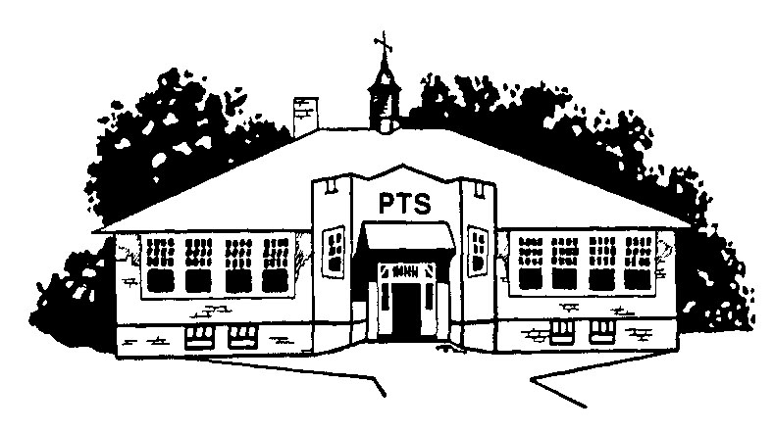
Pemberton Township School District
P.O. BOX 228, ONE EGBERT STREET
PEMBERTON, NEW JERSEY 08068-0228
PHONE: 609-893-8141

Food Allergy/Restriction Questionnaire

In order to ensure the safety of your child at school and assist the classroom teacher, we would like to ask you to complete in as much detail as possible, information regarding foods that your child may have for snack and what foods your child must absolutely avoid. Please be advised that this information will be shared with appropriate school personnel for the safety of your child.

If your child is allergic to nuts please specify which nuts they need to avoid and if there are any nuts they can safely eat. For example, allergy to walnuts and almonds but can have pecans and peanuts.

If your child is allergic to fruits please specify if it is the actual fruit only or if the allergy is to all forms of the fruit. Are artificial flavorings of the fruit acceptable? For example, allergy to apples but can have apple juice, applesauce or apple-flavored candy.

Please specify if the food product they are allergic to needs to be avoided all together or if a certain quantity is acceptable. For example, allergy to milk but can have 2 oz. a day of chocolate milk.

Finally, please provide us with suggested snacks that you normally would provide at home; be very specific about what your child must avoid.
Student name_______________________________________________Grade__________________________

Food allergy/restriction to ___________________________________________________________________

Avoid food totally or limit the amount? _________________________________________________________

May have a limited amount (be specific) ________________________________________________________

My child may be in the same room with other children eating this food product? Yes No

My child must avoid the following prepared foods & baked goods __________________________________
________________________________________________________________________________________

Snacks that my child can eat (be specific) _______________________________________________________

My child is allowed to self select items from the cafeteria and knows his/her restrictions? Yes No
If the above answer is no, then you will need to pack a lunch for your child daily.

When my child has a reaction to eating this food you will see these symptoms__________________________
________________________________________________________________________________________

Medications necessary to treat my child’s reaction to this food allergy are______________________________

If medication is needed at school additional paperwork needs to be completed by you and your child’s doctor.

Check here if you need me to send the appropriate forms home to you or circle from the sentence below.

- My child has (please circle all that apply) been desensitized, no longer has a food allergy, medication is not required at school.

I will indemnify and hold the district and its employees harmless should any problems arise.

Parent Signature_______________________________________________ Date________________________

